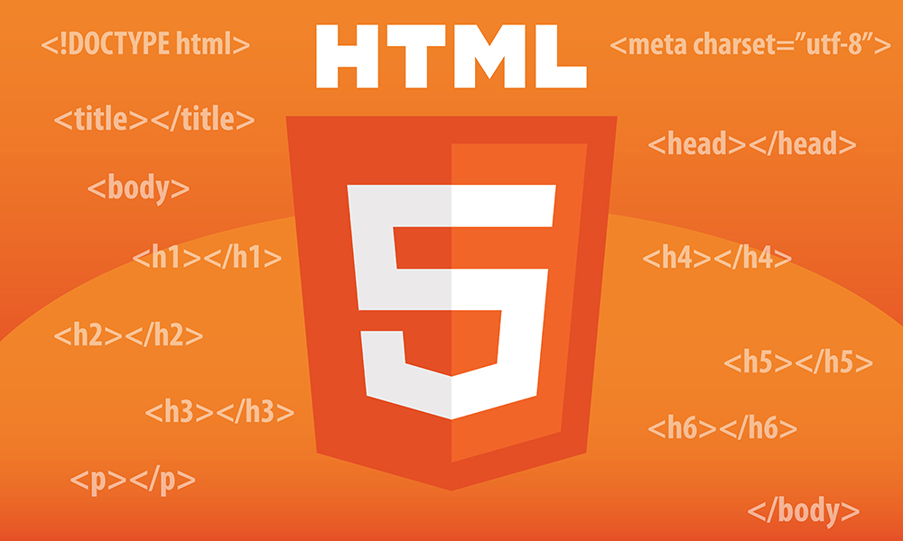

HTML Project

­­

TABLE OF CONTENTS

Breif Review of HTML 3

HTML Project 4

CSS 5

Output....…………………………………………………………………………………………………………………………………………………6



# Introduction

The HyperText Markup Language, or HTML is the standard markup language for document designed to be displayed in a web browser. HTML provides a means to create structured documents by denoting structural semantic for text such as headings, paragraphs, lists, links, quotes and other items.

HTML is the code that is used **to structure a web page and its content**. For example, content could be structured within a set of paragraphs, a list of bulleted points, or using images and data tables.

# Project

A website named “ASUS” is going to sell their products online and this website is their online sales center. In this website, ASUS is selling their top-rated Laptops only. All the laptops are given with their specs available. User should choose specs according to their Money. User mush register before buying any product so there is a a option given to Register. If he is already Register then he/she should simply log in and then purchase the Product.

# Key Findings

## Key Findings #1

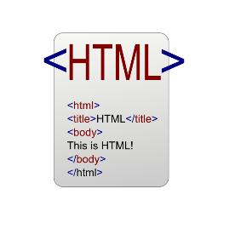

Learn HTML and CSS from the Project

## Key Findings #2

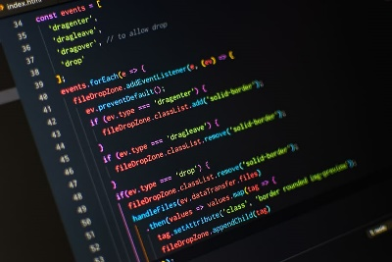

Use Html for web view of the document

## Key Findings #3



Use CSS for better look

# Html

The HTML used this Project is just adding images, addresses, linking pages and buttons. Also, some ordered and unordered lists and Buttons.

There are 4 pages of html which are linked with each other. They are below:

1. Main Page

It is the main interference of the HTML website.

1. Sign Up Page

If the user wants to Register, he should sign up. For this purpose the sign up page is used.

1. Sign In Page

If the user is already Register, then he should use sign in page to log in.

1. If the user wants to buy any Product he will select the Buy button that will take him on Buy Page.

CSS

CSS is the main part of the Project because all the design is written in CSS. There are they ways to use CSS in HTML given below:

1. External
2. Inline
3. Internal

The project uses the internal CSS.

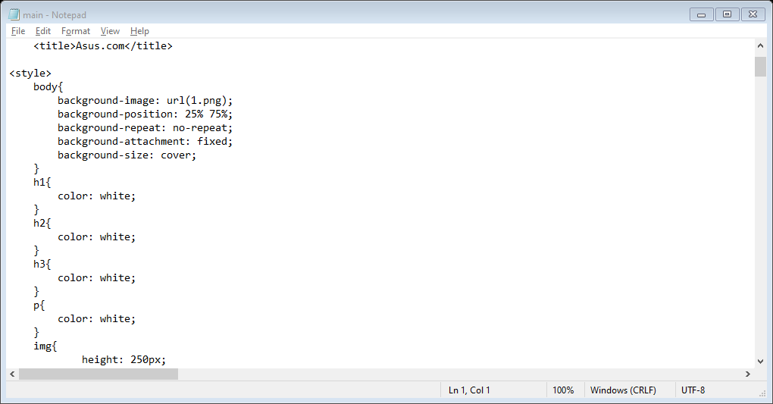

# Conclusion

Time to wrap it up. What is your conclusion? How would you synthesize all the information into something even the busiest CEO wants to read? What are the key takeaways? How does your product/service/methodology uniquely address the issues raised by your study?

## Key Takeaways

* Takeaway #1
* Takeaway #2
* Takeaway #3